(Approx. 1,391 words)

Photoshop CS3
Product Review by Tom Ekvall, newsletter editor for Northeast Wisconsin PCUG
www.webpages.charter.net/newpcug
tekvall(at)new.rr.com

Obtained from APCUG with the author's permission for publication by APCUG member groups.

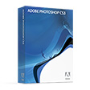
Some things just keep getting better. And the latest release of Photoshop CS3 is no exception.

This new release offers major enhancements that will appeal to present Photoshop users as well as to those interested in transitioning to Photoshop CS3 from Photoshop Elements or other similar products.

As someone doing photo art, my interest in Photoshop CS3 centered on new features related to creating black and white prints and applying “smart filters” to photographs. And there are so many more enhancements to drool over related to everything from an improved interface to a new integrated Adobe Camera Raw that allows working with jpg and tiff images as well as those shot in the raw format.

Previously, I have used Photoshop Elements (Versions 1 through 5) to do my image editing and welcomed the opportunity to transition to Adobe’s flagship product. The latest version, which works with Vista, was simply fantastic to use and not all that difficult to make the transition. There is still a learning curve as the image editing product offers so many opportunities to “tweak” photos to make them look their best. However, there are many resources on-line and in book form to learn how to use the product.

I downloaded the product onto an Acer laptop running Vista Premium with dual-core processors and 2 gigabytes of RAM. After installing the product, I was amazed how fast Photoshop CS3 started up, just ten seconds. For those with previous versions of Photoshop, one will notice a revamped interface that focuses on collapsible palettes docked to the right side of the screen to make it easier to work on photos. This is especially helpful when working on a laptop or when you just don’t want a lot of clutter on the screen.

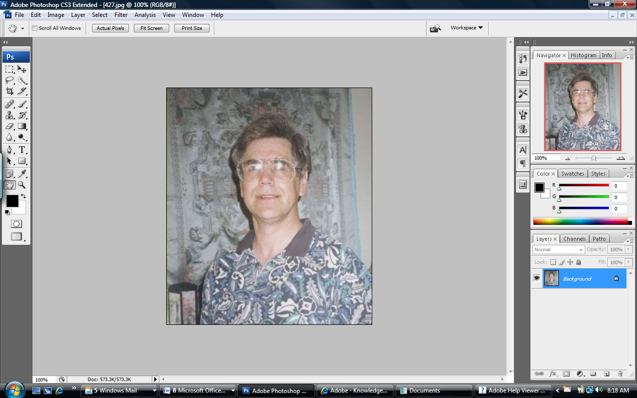

So what is new and improved? Many seem to be aimed at improving workflow performance through enhancing and simplifying the way changes are made.

Here are just some of the features I found of most interest, recognizing my passion for creating art as compared to creating perfect photos.

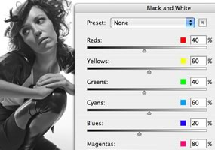
Black and White Enhancement

I have been very much interested in creating black and white photos from color images. Never could get them to look like that from Ansel Adams; however, the digital divide is getting narrower.

Typical ways to create black and white pictures was to either desaturate the photo of color, use the grayscale tool, or use the channels feature. Photoshop Elements 5 introduced a “Convert to Black and White” feature that presented thumbnail images of different effects with less or more of blue, red, and green channels in different styles.

Photoshop CS3 offers a fantastic Black and White adjustment that includes all six colors (cyan, magenta, and yellow in addition to the blue, red, and green) as well as the ability to simply click on a point on the photo and drag either right or left to either lighten or darken the appropriate tones of the photo, giving you more control over the photo. The dialog box also provides opportunities to tint the photo with slider bars for hue and saturation.

Trying out this adjustment, I found the quality of the photo to be much improved over previous ways of creating a black and white photo.

Smart Filters

The next feature I found to be very appealing to me, and undoubtedly to other Photoshop users, is the Smart Filter, a new addition from previous versions.

The Smart Filter feature enables the user to apply non-destructive changes to an image on layers when used in conjunction with Smart Objects. What this means is that I can try out one or more filters to enhance my photo the way I want without that change becoming permanent. This way, if I don’t like the effect now or later, I can remove it, modify it or use a different filter without having to start over at a later point in time. Of course, you can always use the Undo command; but sometimes, you like to make the changes later after you apply another effect and then decide against the earlier filter effect. A layer can be converted to a Smart Object by right-clicking on this feature in the Layers menu.

Non-destructive editing is becoming more popular today, with CS2 introducing the Smart Object feature to layers.

Improved Raw Processing

A significant feature in image editing programs these days is the ability to edit photos shot in the raw format. Those cameras able to shoot in raw tend to be the digital SLR ones, which means that the camera does not make any internal changes to the image, but leaves that up to the software program.

With this release of Photoshop CS3, users can work with Jpg and tif images in Camera Raw 4 rather than only those shot in the raw format. Working with Camera Raw 4 is very enjoyable and provides a histogram of the image and sliders to make various changes, such as white balance, fill lighting, recovery (for highlights) blacks, brightness, contrast, and more. The feature can be accessed through File/Open As and then choosing “Raw.” I especially like the HSL/Grayscale tab, which is new to this product, and gives outstanding control over specific color ranges in the image as you control the amount of each range of ‘color’ in the grayscale image. The saturation tab also enables creating a partial grayscale image with part of the image in black and white (or shades of gray) and other parts in color. This is a favorite of mine in creating photo art. I will definitely be using the Camera Raw 4 feature more often.

There are many other new features too numerous to elaborate on in this review but which will be of interest to current Photoshop users to justify upgrading to this new version.

These include:
- Improved Adobe Bridge, which is the photo organizer and media asset management tool, and includes a loupe to check out sharpness of the picture
- Quick Selection and Refine Edges tool, which enhance capabilities for selecting and masking areas of a photo much like a lasso tool
- Refinement to the Curves tool which adds a histogram similar to that in Camera Raw of CS2
- Enhanced 32-bit HDR (high dynamic range) support (a feature I did not try out but enables bracketed photos to be combined to get the desired highlights and shadows that would not be possible from a single photograph)
- The ability to Auto-Align and Auto-Blend Layers as part of advanced compositing tools
- Enhanced print with preview dialog box that make printing options easier to use for correct colors
- Revamped Clone Stamp tool
- Mobile Device controls
- Enhanced vanishing point
- And the list goes on and on for experienced users.

System requirements include:
- Intel Premium 4, Intel Centrino, Intel Xeon or Intel Core Duo (or compatible) processors
- Microsoft Vista or XP with Service Pack 2 (Macintosh supported including those with multi-core Intel processors with faster performance)
- 512 MB of RAM (the more the better)
- 64 MB of video RAM
- 1 GB of available hard disk space

Photoshop CS3 can be tried out by going to the Adobe website (www.adobe.com) and downloading the product, which is valid for 30 days. All the features are available. A full version of the product runs $649 suggested pricing while an upgrade can run $199 or more. Those upgrading must have at least Photoshop 7 or higher to qualify.

I heartily recommend this product for those who are serious about digital photography who may be thinking of making the plunge from Photoshop Elements While Photoshop CS3 may not have all of the “quick fixes” associated with Photoshop Elements, the product offers exciting features to create great photos and unlimited opportunities to customize settings as your talents develop.

And for those who have a previous version of Photoshop, there are numerous enhancements and new features that justify upgrading. I wonder what remains for the next version.

This article has been provided to APCUG by the author solely for publication by APCUG member groups. All other uses require the permission of the author (see e-mail address above).

